Movement ecology of vulnerable lowland tapirs across a gradient of human disturbance

EP Medici $​^{1,2,3*}$, S Mezzini $​^{4}$, CH Fleming $​^{5,6}$, JM Calabrese $​^{7,8,9}$, MJ Noonan $​^{4}$

1 – Lowland Tapir Conservation Initiative (LTCI), Instituto de Pesquisas Ecológicas (IPÊ), Rodovia Dom Pedro I, km 47, 12960-000, Nazaré Paulista, São Paulo, Brazil.

2 – IUCN SSC Tapir Specialist Group (TSG).

3 – Escola Superior de Conservação Ambiental e Sustentabilidade (ESCAS/IPÊ), Rodovia Dom Pedro I, km 47, 12960-000, Nazaré Paulista, São Paulo, Brazil.

4 – The Irving K. Barber Faculty of Science, The University of British Columbia, Okanagan Campus, 1177 Research Road, Kelowna, BC Canada V1V 1V7.

5 – University of Maryland College Park, College Park, MD, USA.

6 – Smithsonian Conservation Biology Institute, Front Royal, VA, USA.

7 – Center for Advanced Systems Understanding (CASUS), Görlitz, Germany.

8 – Helmholtz-Zentrum Dresden Rossendorf (HZDR), Dresden, Germany.

9 – Department of Ecological Modelling, Helmholtz Centre for Environmental Research (UFZ), Leipzig, Germany.

**\*Corresponding Author**: [medici@ipe.org.br](mailto:medici@ipe.org.br)

**Running head:** Lowland tapir space use

|  |  |  |
| --- | --- | --- |
|  |  |  |
|  |  |  |
| Words in the abstract: XX |  | Number of Figures: XX |
|  |  |  |
| Words in main text: XX |  | Number of tables: XX |
|  |  |  |
| Number of references: XX |  | Supplementary material: XX |

**Statement on human or animal subjects:** The Instituto Chico Mendes de Conservação da Biodiversidade (ICMBIO) provided the required annual permits for the capture and immobilization of tapirs and collection of biological samples (SISBIO# 14,603). The Comissão Técnico-Científica (COTEC) do Instituto Florestal do Estado de São Paulo (IF-SP) provided the required permit to carry out research in Morro do Diabo State Park (SMA# 40624/1996). All protocols for the capture, anesthesia, handling and sampling of tapirs have been reviewed and approved by the Veterinary Advisors of the Association of Zoos and Aquariums (AZA) – Tapir Taxon Advisory Group (TAG), and the Veterinary Committee of the IUCN SSC Tapir Specialist Group (TSG).

# To Do List:

* Add better maps under the tracking data and HRs
* Switch to metafor for the tests.
* Create boxplots and/or a descriptive table of the habitat composition of the three study sites (proportions of each habitat class within the extent of the tracking data). Compile these into supplementary material.
* Create boxplots of the proportions of the different habitat layers within HRs across the three different biomes, for males/females, and for age classes. Compile these into supplementary material.
* Create a csv file with summary stats for each animal (ID, sampling duration, sampling interval, sampling type, biome, HR size, habitat proportions, HFI, etc.) to be included as supplementary material.

# Abstract

**Keywords:**

# Introduction

While agriculture, urbanisation, and transportation infrastructure are critical to human socio-economic improvement (Esfahani and Ramı́rez 2003), the associated habitat transformations represent a major threat to species survival (Fahrig 1997; Venter et al. 2006; Powers and Jetz 2019). Of particular concern is the impact of human activities on animal movement and space use (Allen and Singh 2016; Tucker et al. 2018; Doherty, Hays, and Driscoll 2021). Animal movement governs how individuals, populations, and species interact with each other and the environment (Schick et al. 2008; Martinez-Garcia et al. 2020; He et al. 2021) and mediates key ecological processes (Bauer and Hoye 2014). The capacity for individuals to move unhindered across complex landscapes is therefore critical for species survival and ecosystem function. Problematically, human development has been reducing the amount of habitat available to wildlife (Brooks et al. 2002; Cardinale et al. 2012; Hooper et al. 2012). This has spurred substantial changes in animal movement behaviour across the globe (Fahrig 2007; Tucker et al. 2018; Doherty, Hays, and Driscoll 2021), with potential consequences including reduced fitness and survival, altered predator-prey dynamics, reduced seed dispersal, genetic isolation and local extinction (Fahrig 2007; Dickie et al. 2017; Cosgrove, McWhorter, and Maron 2018; Tucker et al. 2021).

Notably, human disturbance has been shown to have differential effects across species (Toews, Juanes, and Burton 2018; Doherty, Hays, and Driscoll 2021), even for closely related taxa occupying the same habitat (Thatte et al. 2020). Responses to human activities are thus largely taxa and context specific (Doherty, Hays, and Driscoll 2021) and there are no clear *a priori* expectations as to how any given species might be expected to respond to human disturbance. For instance, although Wall et al. (2021) found a tendency for African elephants (*Loxodonta spp.*) to exhibit reduced movement in human modified landscapes, Morato et al. (2016) noted that jaguars (*Panthera onca*) living in regions with high human population densities in South America occupied home ranges that were orders of magnitude larger than those of jaguars living in more pristine habitats. As human disturbance is only expected to worsen over the next decade it is critical to better understand how species respond to human disturbance in order to develop effective, case-specific conservation strategies. To this end, here we focus on understanding how the movement behaviour of lowland tapirs (*Tapirus terrestris*, henceforth ‘tapirs’) varies across a gradient of human disturbance within three biomes in southern Brazil, the Pantanal, Cerrado, and Atlantic Forest. Lowland tapirs are herbivores of the order Perissodactyla that can reach over 2.5 meters and weigh up to 250kg (E. P. Medici 2011). While tapirs are distributed throughout South America (Gardner 2008), their populations have suffered severe reductions, with local and regional extirpations, and are currently classified as vulnerable to extinction (Varela et al. 2019).

Although the incorporation information on animal movement is a key component in designing effective conservation and recovery strategies (Allen and Singh 2016), currently, very little is known about the movement ecology of tapirs (but see Noss et al. 2003; Tobler 2008; C. H. Fleming et al. 2019). This knowledge gap is especially pertinent given that large terrestrial mammals - such as tapirs - tend to have larger home ranges and greater absolute mobility than do small mammals (Calder 1983; Michael J. Noonan et al. 2020), making them more susceptible to anthropogenic impacts than smaller bodied species (Tucker et al. 2018; Hill et al. 2020). Here, we use an extensive telemetry dataset collected over 22 years to describe the movement ecology of tapirs and study how changes in human disturbance influence their movement and space use. Because human activity tends to result in increased movement for large herbivores (Doherty, Hays, and Driscoll 2021) our underlying hypothesis was that tapirs should exhibit greater movement distances and larger home range areas when living in human-modified landscapes. Further, animals living in highly productive environments do not need to range over wide areas to meet their energetic needs (Lucherini and Lovari 1996; Relyea, Lawrence, and Demarais 2000; Nilsen, Herfindal, and Linnell 2005). As such, we expect that tapirs should adjust their movement and space use according to local environmental conditions. Findings from this work fill a critical knowledge gap in lowland tapir ecology and can contribute to long-term species management and conservation strategies.

# Methods

## Study area and data collection

The data was collected in three different biomes in southern Brazil (Fig. 1): Atlantic Forest (1997-2007), Pantanal (2008-2019), and south-western Cerrado (2016-2018).

### Atlantic Forest

Morro do Diabo State Park is a protected area located in the Municipality of Teodoro Sampaio (22°32’S, 52°18’W), state of São Paulo, in the southeastern region of Brazil. The Park has an area of 370 km² composed by a mosaic of mature and secondary deciduous forest, surrounded by the Paranapanema River in the south, and by a matrix of cattle ranches and agriculture, mostly sugar cane, in the remaining borders (Uezu, Beyer, and Metzger 2008). Its average annual temperature is 22°C; annual rainfall is 1347 mm (Faria and Pires 2006) [I DON’T KNOW WHAT CITATION THIS IS. PATI CAN YOU GIVE ME THE DETAILS?]. The Park is part of the “Planalto Forest,” which distinguishes from the coastal forest of the Atlantic Forest biome by having lower annual rainfall and a marked dry season from May to September, more similar to the Cerrado biome (Salis, Shepherd, and Joly 1995). In fact, the semideciduous forests of the “Planalto Forest” are similar to those occurring within or on the edges of the Cerrado (Salis, Shepherd, and Joly 1995).

### Pantanal

Baía das Pedras Ranch, a private property of 145 km², is located in the Nhecolândia Sub-Region of the Southern Pantanal, Municipality of Aquidauana (19°20’S, 55°43’W), Mato Grosso do Sul State, in the central-western region of Brazil. The ranch includes a mosaic of seasonally inundated grasslands, lakes, gallery forests, scrub, and deciduous forests that supports an abundance of wildlife. Cattle are raised extensively over native grasses. The average annual temperature is 25°C; annual rainfall is 1185 mm (Calheiros and FONSECA JÚNIOR 1996).

### Cerrado

The study site in the Cerrado biome is a mosaic of private properties (cattle ranches and farms) and landless people settlements, 2200 km², within the Municipalities of Nova Alvorada do Sul and Nova Andradina, Mato Grosso do Sul State (21°60’S, 53°83’W). The area includes small fragments of natural Cerrado habitat (Cerradão fragments, gallery forests, and marshland - 25% of the study area), surrounded by areas highly impacted by human activities such as agriculture (particularly sugarcane, soybean and corn), cattle-ranching (cultivated pastureland), Eucalyptus plantations, rural communities, and highways. The average annual temperature is 25°C; annual rainfall is 1185 mm.

In each study site, tapir captures were accomplished by darting after physical restraint in either (i) box traps or (ii) pitfall traps or (iii) by darting from a distance (Quse, Fernandes-Santos, and others 2014). Animals were anesthetized mostly using a combination of butorphanol, medetomidine and ketamine, as described by Emı́lia Patrı́cia Medici, Mangini, and Fernandes-Santos (2014) and Fernandes-Santos et al. (2020). Reversal agents were administrated at the end of procedures.

The procedures carried out during immobilization included the subcutaneous insertion of a microchip, morphometric measurements, sex and age class determination, physical examination, collection biological samples for health and genetic studies, and placement of a telemetry collar on adults. Animals were tracked using VHF tracking (all three regions; Telonics® MOD500) and GPS tracking (Pantanal and Cerrado; Telonics® TGW SOB and GPS IRIDIUM models). A total of 74 tapirs were tracked starting in July of 1997 until October of 2019, with the majority of the data being in the Pantanal (46), while 17 and 11 were from the Cerrado and Atlantic Forest regions, respectively.

Tapirs equipped with VHF collars were monitored for 5 days per month with data collection concentrated during crepuscular times, 3 hours at dawn (04:00-07:00 h) and 3 hours at dusk (17:00-20:00 h). These periods are the two main peaks of tapir activity (E. P. Medici 2011). Each tapir was located every 30 minutes during the sampling periods. GPS collars were programmed to obtain a fix every hour and operated for a median of XXX months across all tagged tapirs. GPS fix success rates were 75% in the Pantanal and 90% in the Cerrado. The full dataset comprised 232,622 location estimates collected over a period of 22 years (for full details see Appendix XX).

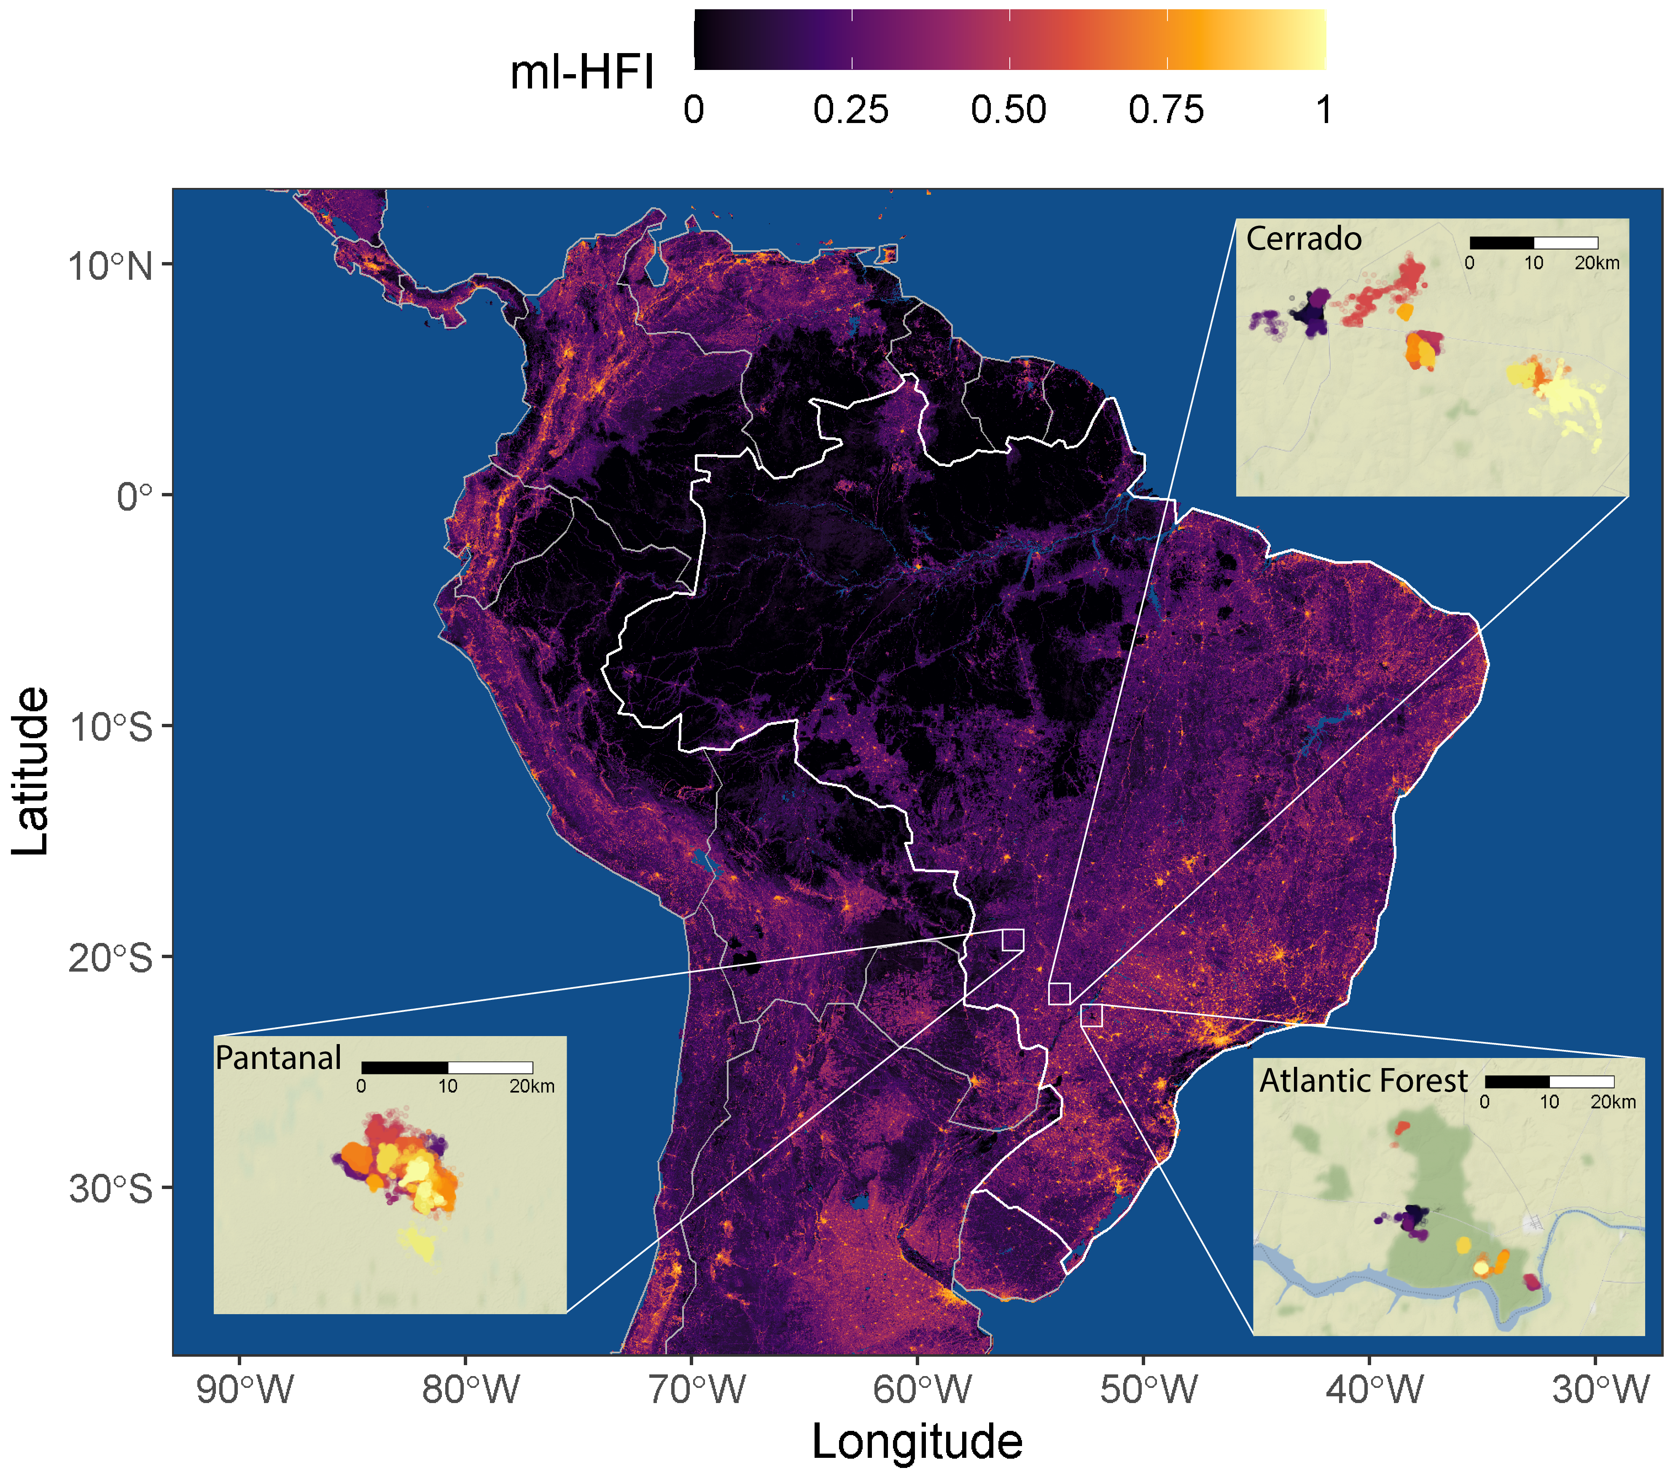

Figure 1: Location of the tree study sites (Pantanal, Cerrado, Atlantic Forest) over a raster of machine-learning-based human footprint index (ml-HFI), an index of human pressure on the landscape that is derived from remotely sensed surface imagery and ranges on a scale between 0 (no human impact), and 1 (high human impact).

## Data analysis

All statistical analysis and plotting were performed using R (version 4.0.5, R Core Team 2021) using packages ctmm (version 0.6.1, “Ctmm: Continuous-Time Movement Modeling,” n.d.), mgcv (version 1.8-36, Wood 2017), ggplot2 (version 3.3.4, Wickham 2016), ggmap (version 3.0.0, Kahle and Wickham 2013). The furrr package (version 0.2.2, Vaughan and Dancho 2021) was used for parallel computation on Windows machines. All R code can be found in the GitHub repository at <https://github.com/StefanoMezzini/tapirs>.

### Data calibration and cleaning

Before analysis, we performed an error calibration and data cleaning process in order to minimise the impacts of GPS measurement error and outliers on our subsequent analyses (C. H. Fleming et al. 2020). Data cleaning and calibration were carried out using the methods methods implemented in the ctmm R package (“Ctmm: Continuous-Time Movement Modeling,” n.d.). For this process, location estimates collected via VHF telemetry were assumed to be free from any meaningful measurement error and raw, uncalibrated locations were carried forward in the analyses. Location estimates collected via GPS tracking were calibrated using a unitless Horizontal Dilution of Precision (HDOP), which estimated the accuracy of each positional fix. We then estimated an equivalent range error with the HDOP values from 883 and 174 measurements from tags in fixed locations in the Pantanal and Cerrado, respectively. This allowed for the unitless HDOP values to be converted into estimates of measurement error in meters. After calibration, data points were considered as outliers (and removed) if they had a large (error-informed) distance from the median location and the minimum speed required to explain the displacement was unusually high ($≥1$ m/s). The Atlantic Forest dataset contained a total of 4,082 observations, 8 of which were removed as outliers; the Pantanal dataset contained 139,138 observations, 914 of which were removed; while the Cerrado dataset contained 90,402 observations, 193 of which were removed.

### Movement modelling and home range estimation

For each of the monitored tapirs we quantified a number of key movement metrics and home range related characteristics that allowed us to test for an effect of human disturbance on tapir movement behaviour. For this we first identified the best Continuous-Time Movement Model (CTMM) for each animal using the ctmm.select function from the ctmm package. This fits a series of CTMMs to location data using perturbative Hybrid Residual Maximum Likelihood (pHREML, Christen H. Fleming et al. (2019)) and chooses the best model using small-sample-sized corrected Akaike’s Information Criterion (AICc). The models used here are insensitive to sampling frequency (Michael J. Noonan et al. (2019)) and they account for spatio-temporal autocorrelation in the data (when necessary), so they are robust to irregular or frequent sampling frequency (C. H. Fleming et al. 2018), HR underestimation (M. J. Noonan et al. 2019), and significance inflation (Christen Herbert Fleming et al. 2021). The parameter estimates from each individual’s movement model provided information on the tapir’s home range crossing time ($τ_{p}$, in days), and directional persistence timescale ($τ_{v}$, in hours).

We then conditioned off of the selected CTMMs to estimated each animal’s 95% home range (HR) area (in km $​^{2}$) using small-sample-size bias corrected Autocorrelated Kernel Density Estimation (AKDE) (Christen H. Fleming and Calabrese 2017), and average daily speed (in km/day) using continuous-time speed and distance (CTSD) estimation (Michael J. Noonan et al. 2019).

### Movement pattern analyses

We were first interested in understanding how home-range areas and movement metrics differed across the three biomes, as well as between animals of different age and sex. For these comparisons, home range estimates were compared using the meta-analysis methods implemented in the ctmm package (Christen Herbert Fleming et al. 2021), whereas other movement metrics were analysed using the meta-regression model implemented in the R package metafor (Viechtbauer 2010), which allowed uncertainty in each individual estimate to be propagated into the population level estimate when making comparisons.

To test whether tapirs responded to different environment types, the HR sizes and average daily speeds were regressed against the proportions of the habitat types in each HR. [PATI, WE NEED A BIT OF DETAIL HERE ABOUT HOW THE HABITAT LAYERS WERE GENERATED] Similarly, the HR sizes and average daily speeds were regressed against their HR’s average machine-learning-based human footprint index (ml-HFI) (Keys, Barnes, and Carter 2021) to test whether environmental modification significantly altered the animals’ behavior. The ml-HFI is an index of human pressure on the landscape that is derived from remotely sensed surface imagery and ranges on a scale between 0 (no human impact), and 1 (high human impact). For these models we applied Generalized Additive Models (GAMs) with a Gamma distribution and a log link function for the response. The Gamma distribution allows for more accurate significance testing and is an appropriate distribution for variables that range between 0 and $∞$, while the log link scale allows HFI to have a multiplicative effect on the response. The GAMs were fit using the mgcv package (Wood 2017) and Restricted Maximum Likelihood (REML), and the best model was selected using AIC.

# Results

[I THINK THESE RESULTS SHOULD ULTIMATELY END UP IN SUPPLEMENTARY MATERIAL] There was no significant difference in the home range estimates between individuals who were monitored using GPS collars, VHF tracking, or a mixture of the two (GPS as the control, p-values: 0.495 for GPS and VHF, 0.739 for VHF only, see Fig. 2).

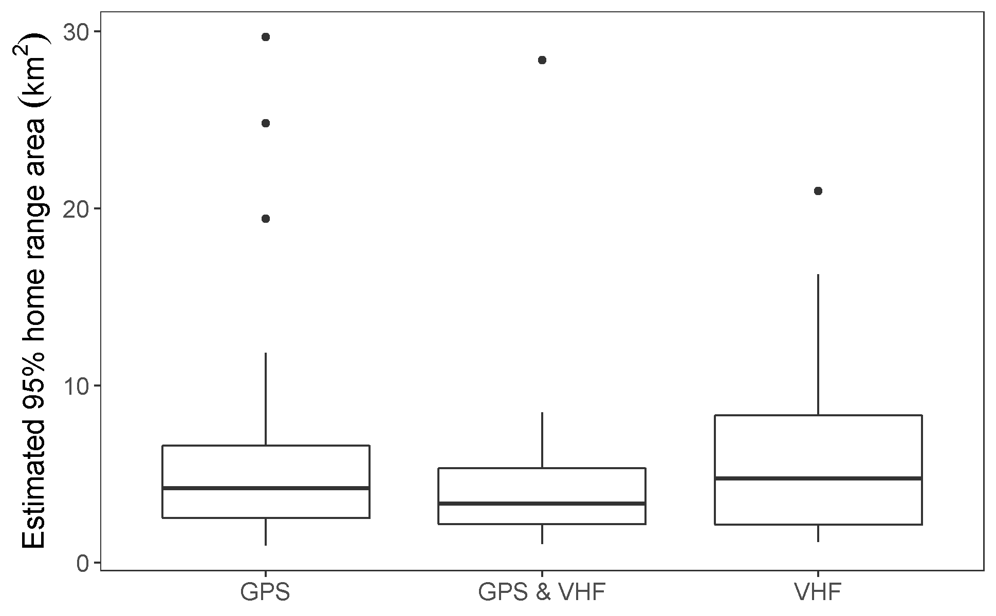

Figure 2: Estimated 95% home range area by tracking method. Tapirs were monitored using GPS collars, Very High Frequency (VHF) tracking, or both.

## Individual variation in movement and space use

*change values to more appropriate estimates; currently using mean +/- 1.96 sd/sqrt(n)*

The mean home range size across all monitored tapirs was 5.82 km $​^{2}$ (95% CI: 4.71 - 7.12; Fig. 3), ranging between 1 km $​^{2}$ and 29.7 km $​^{2}$ (Fig. 4a). Tapirs had HR crossing times of 0.72 days on average (95% CI: 0.35 - 1.10), ranging from 0.05 to 12.8 days (Fig. 4b), and a mean velocity autocorrelation timescale of 0.44 hours (95% CI: 0.39 - 0.49), ranging from 0.17 to 1.88 hours (Fig. 4c). We estimated that tapirs had mean movement speeds of 11.2 km/day (95% CI: 10.2 - 12.1), ranging from 1.51 to 25.96 km/day (Fig. 4d). There was no evidence that average daily speed differed between sexes (females: 10.5 km/day, 95% CI: 9.19 - 12.0; males: 11.9 km/day; 95% CI: 10.3 - 13.7, $p=0.22$, 5a), and there was little to no evidence of it differing between age groups (adults: 11.8 km/day, 95% CI: 10.6 - 13.2; sub-adults: 9.52 km/day, 95% CI: 7.94 - 11.4; $p=0.053$, Fig. 5b).

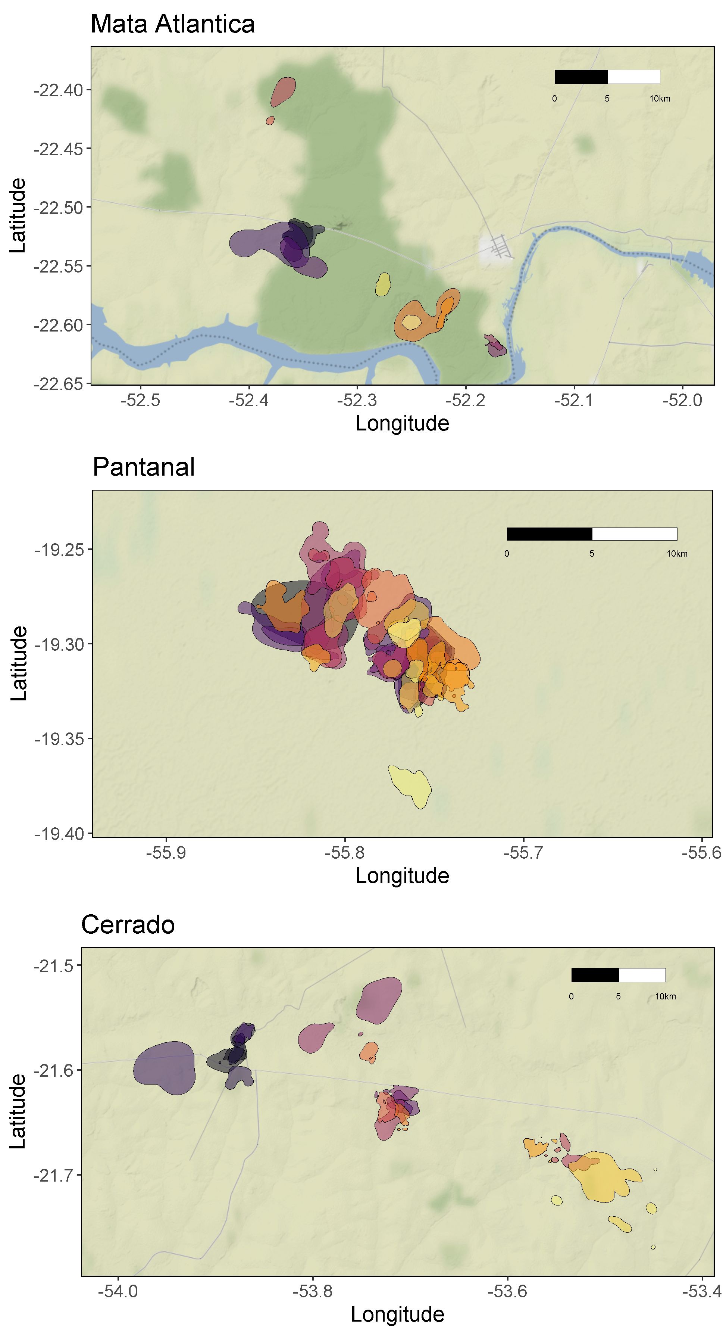

Figure 3: Autocorrelated kernel density estimations of each tapir’s 95% home range.

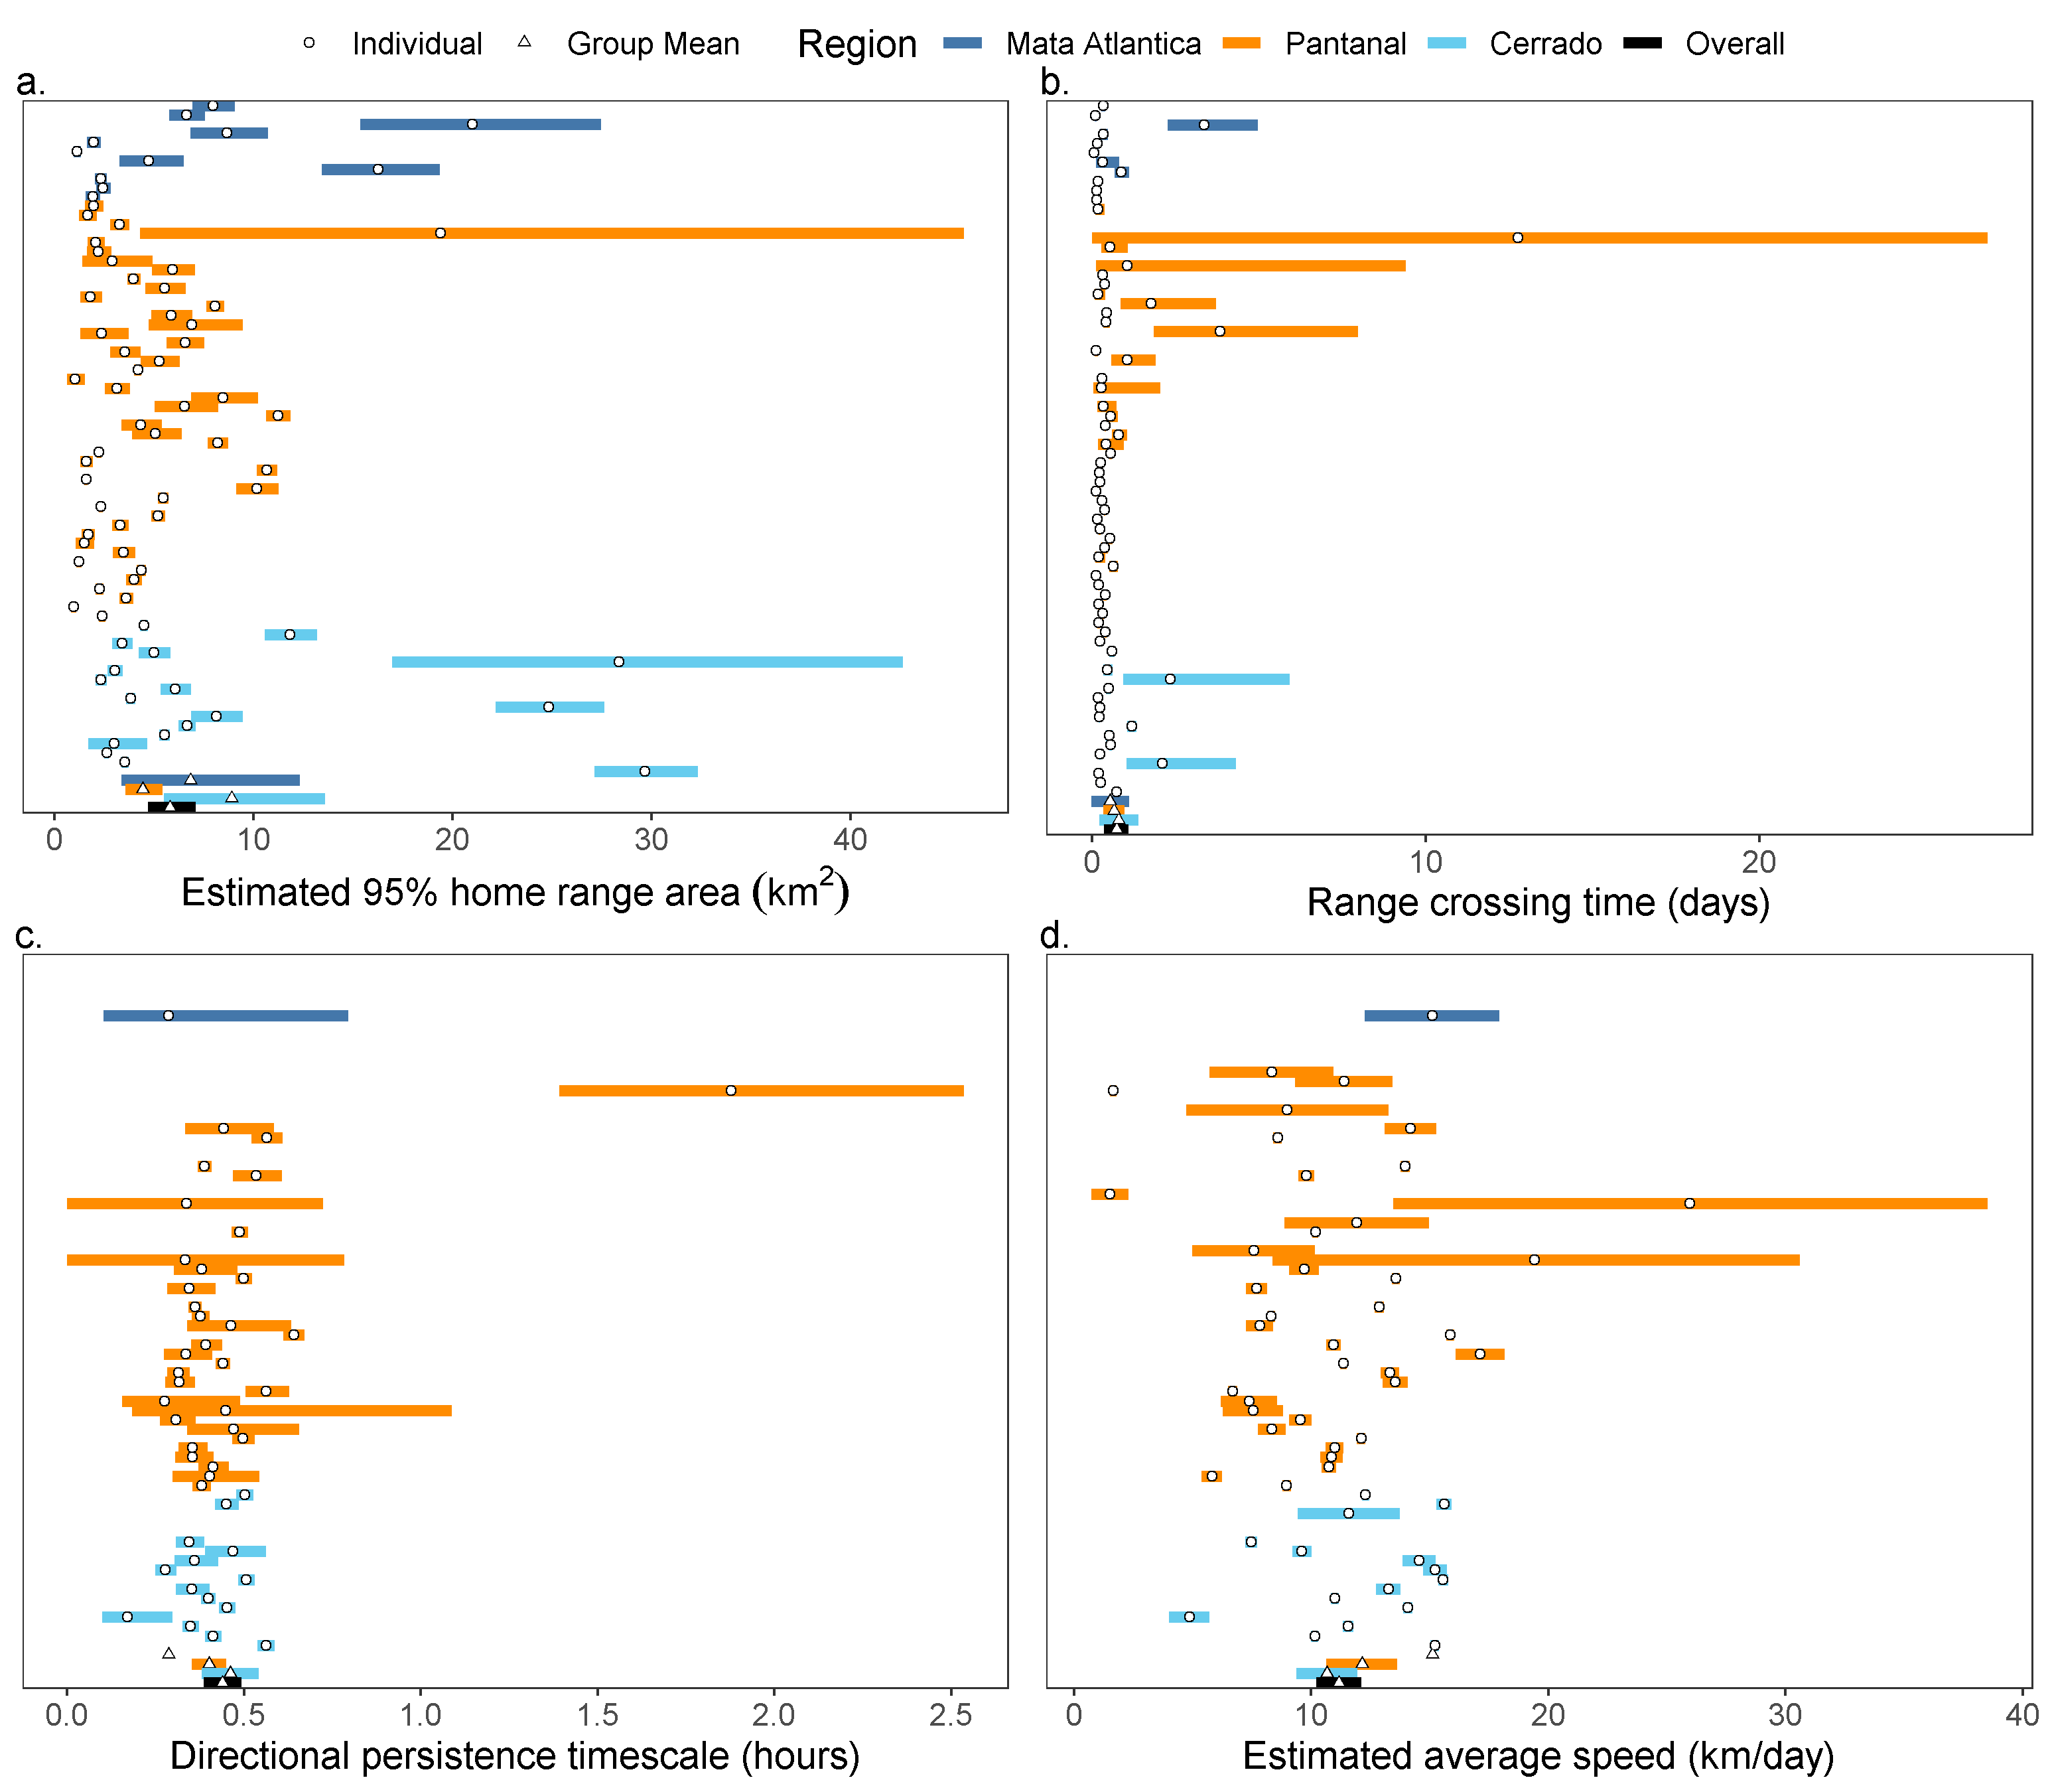

Figure 4: Parameter estimates from each tapir’s movement model (circles) and group means (triangles), with 95% confidence intervals. Individuals with a movement model that does not allow for inferences in movement speed are left blank.

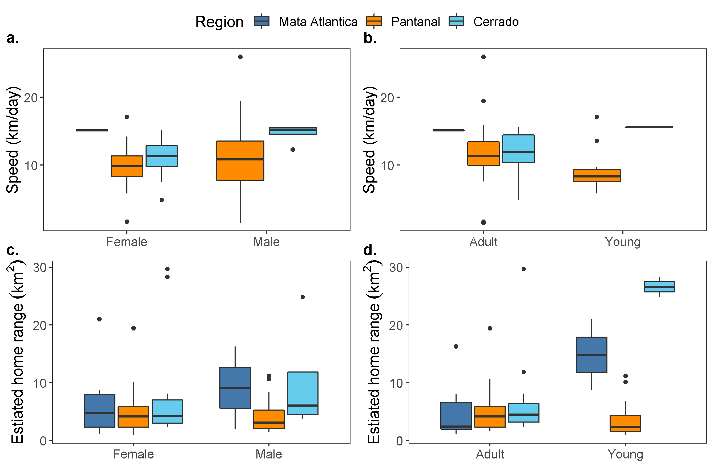

Figure 5: Boxplots of daily average speed (a, b) and estimated home range size (c, d) by sex and age group.

There was no evidence that home ranges sizes differed between sexes (males: 5.43 km $​^{2}$, 95% CI: 3.84 - 7.68; females: 6.27 km $​^{2}$, 95% CI: 4.64 - 8.48; $p=0.541$, Fig. 5c) nor between age groups (adults: 5.47 km $​^{2}$, 95% CI: 4.21 - 7.1; sub-adults: 7.01 km $​^{2}$, 95% CI: 4.63 - 10.6; $p=0.324$, Fig. 5d).

## Variation in movement across biomes and gradients of human disturbance

The Atlantic Forest, Cerrado, and Pantanal vary substantially in habitat composition, levels of human disturbance, and tapir population densities. Despite these differences, we found that lowland tapir movement behaviour and space use were consistent across all three biomes (Fig. 4.

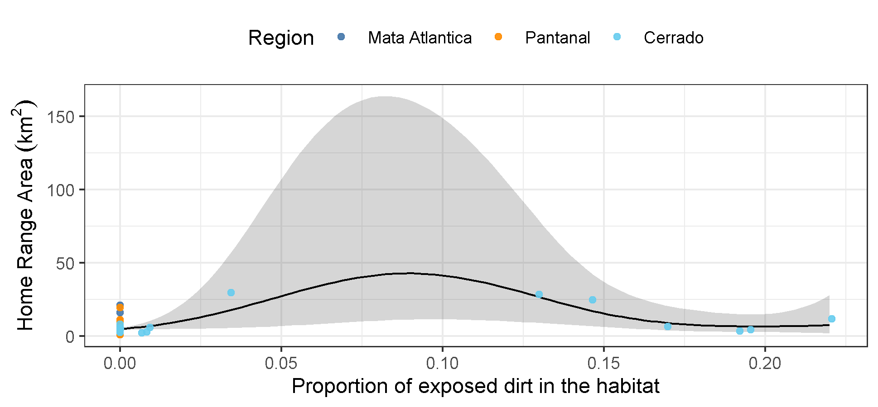

Figure 6: Estimated mean effect of exposed dirt on the tapirs’ estimated home range area.

We also found that habitat type had little effect on HR area or average individual movement speeds (Fig. lu-reg). The best HR area model only accounted for the effect of areas of exposed soil (approximate p-value: 0.023, $R_{adj}^{2}$ = 0.477), while no land use types had a significant effect on an animal’s average speed. There was very little difference between the AIC of the full model (312.51, df = 11.41, 8 predictors) and that of the model with not predictors but the intercept term (310.89, df = 2).

HFI had no significant effect on either lowland tapir home range size (p-value = 0.90; Fig. 7a), nor average daily movement speed (p-value = 0.53; Fig. 7b). A tapir living in a near pristine environment (HFI = 0.004) was estimated to have a home range of 7.77 km $​^{2}$ (95% CI: 2.12 - 28.6) and an average speed of 13.19 km/day (95% CI: 7.82 - 22.1), while a tapir from the most altered habitat we monitored (HFI = 0.31) had an estimated home range area of 6.93 km $​^{2}$ (95% CI: 3.36 - 14.3) and an average speed of 10.43 km/day (95% CI: 8.27 - 13.2).

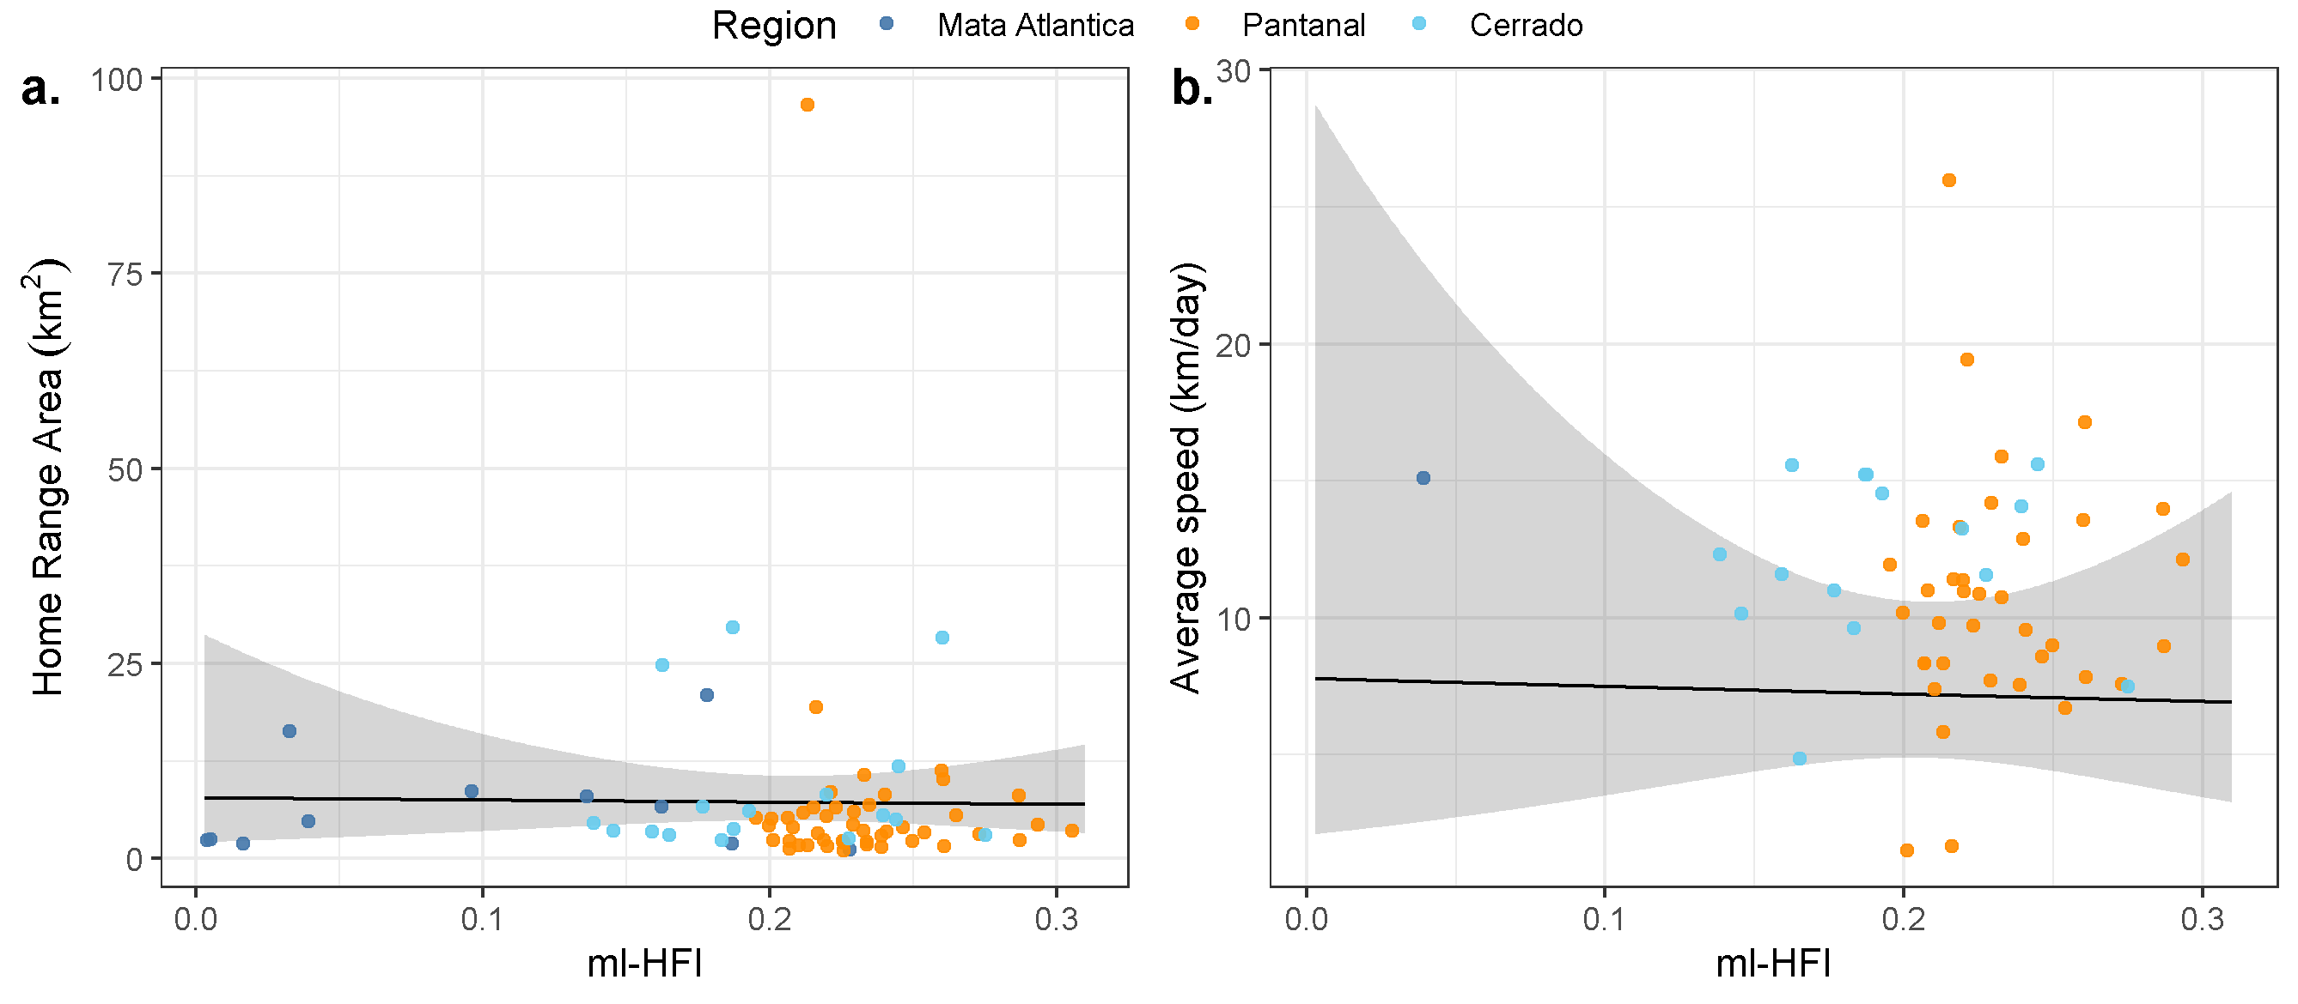

Figure 7: Estimated mean effect of machine-learning-based human footprint index (ml-HFI) on the tapirs’ estimated home range area and estimated average daily speed.

# Discussion

Understand individual movement and space use requirements is a key step in conservation planing (Allen and Singh 2016). Prior to the present study, however, very little was known about the movement ecology of tapirs despite their vulnerable status and declining population sizes (Varela et al. 2019). From detailed tracking of 74 tapirs collected over 22 years, we found that individuals showed very little inter-individual variation in movement despite occupying substantially different habitats across a gradient of human disturbance. Overall, human activity and land use change did not appear to significantly affect their behaviour one way or another. This contradicts patterns in large herbivores generally (Tucker et al. 2018; Doherty, Hays, and Driscoll 2021), and further emphasises the need to obtain sound empirical data on animal movement when designing conservation and recovery strategies.

## Lowland tapir space use

Interestingly, we found that the home range sizes and mean daily movement speeds of lowland tapirs were consistent across the three study sites. This consistency in movement was surprising as these different biomes had substantially different habitat compositions, patterns of seasonality, and productivity [Morato et al. (2016); see also Apendix SXXX]. Tapirs living in the Pantanal, for instance, must cope with significant seasonal flooding, whereas individuals in the Cerrado occupied an agricultural mosaic with more stability across seasons. Nonetheless, the unique requirements of the different biomes did not impact the mean space use and daily movement speed of tapirs. Furthermore, the only pre-existing study on tapir movement found that individuals had complex home range structures, with multiple core areas of use that were established according to the distribution of patches of preferred habitat types (Tobler 2008). In the present study, however, we found that habitat composition had no effect on home range sizes. In addition to exhibiting little inter-individual variation in movement, variogram analysis (Chris H. Fleming et al. 2014) showed the tapir movement was vary consistent over time (see also C. H. Fleming et al. 2019). Here again, this seasonal stability in movement was interesting, especially for animals living in the Pantanal where, every year, large parts of the biome change from terrestrial into aquatic habitats and vice-versa (Alho 2008).

We did find that animals with a higher proportion of forest and/or more water bodies in their home ranges had shorter velocity autocorrelation timescales and more tortuous movement. This shows how habitat complexity can impact movement (Dickie et al. 2017), with potential implications for foraging efficiency and encounter rates (Visser and Kiørboe 2006; Bartumeus et al. 2008).

## Lowland tapir movement across a gradient of human disturbance

[HOW DO TAPIR DENSITIES VARY ACROSS THE THREE BIOMES? WOULD BE GOOD TO INCORPORATE THAT INFORMATION INTO THE DISCUSSION] This is the first study aimed at understanding how lowland tapir space use and movement vary across differing degrees of human disturbance. Contrary to our initial expectation, and to patterns in large herbivores generally (Doherty, Hays, and Driscoll 2021), human impacts on the landscape also had no measurable effect on tapir movement. Tapirs inhabiting the Atlantic Forest, the most disturbed biome with only 12% of habitat remaining (Uezu, Beyer, and Metzger 2008), had home range sizes that were comparable in size to tapirs inhabiting the Cerrado, a biome that has lost 50% of its natural area (Machado et al. 2004), and the Pantanal, a relatively pristine biome.

Humans are directly responsible for more than one-quarter of global terrestrial vertebrate mortality (Hill, DeVault, and Belant 2019). Mortality at this scale is expected to impose strong selection pressure on animal populations (Oro et al. 2013; Swaddle et al. 2015). As genotypic adaptation takes generations to occur (Barnosky and Kraatz 2007), behavioral plasticity provides the most immediate response to the pressures of Human Induced Rapid Environmental Change (HIREC, Sih, Ferrari, and Harris 2011). The capacity for behavioural plasticity in movement and space use in response to human disturbance is especially important for long-lived, K-selected species such as tapirs (Rosenheim and Tabashnik 1991; Sih, Ferrari, and Harris 2011; Montgomery, Macdonald, and Hayward 2020) that take years to reach sexual maturity, and have long inter-generational times (E. P. Medici 2011). Despite the key importance of behavioural adaptations in response to HIREC, tapir movement behaviour appeared to exhibit very little plasticity in response to human disturbance. The lack of any measurable response to human activity suggests that tapirs living near humans risks experience increased exposure to vehicle collisions (E. Medici 2019), pesticide and environmental pollutants (Emı́lia Patrı́cia Medici, Mangini, and Fernandes-Santos 2014; Fernandes-Santos et al. 2020), and poaching (Sanches et al. 2011). Human modified habitats thus represent an ecological trap (Schlaepfer, Runge, and Sherman 2002) for tapirs as individuals showed no detectable responses to substantial degradations in habitat quality. Although tapir home range area and mean daily movement speed exhibited no statistically detectable response to the human footprint index, it is possible that individuals are responding to human disturbance at a finer temporal and/or spatial scale than the long-term averages that were examined here. Future investigation into tapir behaviour via step selection functions (Avgar et al. 2016) or the analysis of instantaneous movement speeds Michael J. Noonan et al. (2021) is clearly warranted.

## Conservation implications

[PATI, IT WOULD BE GREAT TO GET GUIDANCE ON THIS SECTION GIVEN YOUR EXPERINCE WITH THE FACTORS THAT ARE IMPORTANT FOR TAPIR CONSERVATION]

## Conclusions

We compared home range areas and movement behavior of lowland tapirs using telemetry data collected over 22 years across 3 biomes in southern Brazil, the Pantanal, Cerrado, and Atlantic Forest. These data represent the largest lowland tapirs tracking dataset yet to be collected, with over 232,000 locations from 74 tracked individuals. Contrary to our expectations, we observed very little individual variability in space use and movement, and human impacts on the landscape also had no measurable effect on tapir movement. Tapir movement behaviour thus appears to exhibit very little phenotypic plasticity. Our findings fill a critical knowledge gap in lowland tapir ecology and can contribute to long-term species management and conservation.

# Acknowledgments

The study of tapir movement ecology has been an important component of the long-term activities of the Lowland Tapir Conservation Initiative (LTCI) – Instituto de Pesquisas Ecológicas (IPÊ) in Brazil. The LTCI has the institutional support from the International Union for Conservation of Nature (IUCN) Species Survival Commission (SSC) Tapir Specialist Group (TSG), Association of Zoos and Aquariums (AZA) Tapir Taxon Advisory Group (TAG), and European Association of Zoos and Aquariums (EAZA) Tapir Taxon Advisory Group (TAG). LTCI’s financial support comes from national and international agencies, including zoological institutions, foundations, private businesses, and private individuals. MJN was supported by an NSERC Discovery Grant RGPIN-2021-02758. This work was partially funded by the Center of Advanced Systems Understanding (CASUS) which is financed by Germany’s Federal Ministry of Education and Research (BMBF) and by the Saxon Ministry for Science, Culture and Tourism (SMWK) with tax funds on the basis of the budget approved by the Saxon State Parliament. CHF, and JMC were supported by NSF IIBR 1915347. EPM would like to thank the Smithsonian Conservation Biology Institute (SCBI) for hosting her for a 2-month research visit for initial data processing and analysis.

# References

Alho, Cleber José Rodrigues. 2008. “Biodiversity of the Pantanal: Response to Seasonal Flooding Regime and to Environmental Degradation.” *Brazilian Journal of Biology* 68: 957–66.

Allen, Andrew M, and Navinder J Singh. 2016. “Linking Movement Ecology with Wildlife Management and Conservation.” *Frontiers in Ecology and Evolution* 3: 155.

Avgar, Tal, Jonathan R Potts, Mark A Lewis, and Mark S Boyce. 2016. “Integrated Step Selection Analysis: Bridging the Gap Between Resource Selection and Animal Movement.” *Methods in Ecology and Evolution* 7 (5): 619–30.

Barnosky, Anthony D, and Brian P Kraatz. 2007. “The Role of Climatic Change in the Evolution of Mammals.” *BioScience* 57 (6): 523–32.

Bartumeus, Frederic, Jordi Catalan, GM Viswanathan, EP Raposo, and MGE Da Luz. 2008. “The Influence of Turning Angles on the Success of Non-Oriented Animal Searches.” *Journal of Theoretical Biology* 252 (1): 43–55.

Bauer, Silke, and Bethany J Hoye. 2014. “Migratory Animals Couple Biodiversity and Ecosystem Functioning Worldwide.” *Science* 344 (6179): 1242552.

Brooks, Thomas M, Russell A Mittermeier, Cristina G Mittermeier, Gustavo AB Da Fonseca, Anthony B Rylands, William R Konstant, Penny Flick, et al. 2002. “Habitat Loss and Extinction in the Hotspots of Biodiversity.” *Conservation Biology* 16 (4): 909–23.

Calder, W A, III. 1983. “Ecological scaling: mammals and birds.” *Annual Review of Ecology and Systematics*.

Calheiros, Débora Fernandes, and Wilson Correa da FONSECA JÚNIOR. 1996. *Pespectivas de Estudos Ecológicos Sobre o Pantanal*. EMBRAPA-CPAP Corumbá.

Cardinale, Bradley J, J Emmett Duffy, Andrew Gonzalez, David U Hooper, Charles Perrings, Patrick Venail, Anita Narwani, et al. 2012. “Biodiversity Loss and Its Impact on Humanity.” *Nature* 486 (7401): 59–67.

Cosgrove, Anita J, Todd J McWhorter, and Martine Maron. 2018. “Consequences of Impediments to Animal Movements at Different Scales: A Conceptual Framework and Review.” *Diversity and Distributions* 24 (4): 448–59.

“Ctmm: Continuous-Time Movement Modeling.” n.d. <https://github.com/ctmm-initiative/ctmm, https://groups.google.com/g/ctmm-user>.

Dickie, Melanie, Robert Serrouya, R Scott McNay, and Stan Boutin. 2017. “Faster and Farther: Wolf Movement on Linear Features and Implications for Hunting Behaviour.” *Journal of Applied Ecology* 54 (1): 253–63.

Doherty, Tim S, Graeme C Hays, and Don A Driscoll. 2021. “Human Disturbance Causes Widespread Disruption of Animal Movement.” *Nature Ecology & Evolution* 5 (4): 513–19.

Esfahani, Hadi Salehi, and Marı́a Teresa Ramı́rez. 2003. “Institutions, Infrastructure, and Economic Growth.” *Journal of Development Economics* 70 (2): 443–77.

Fahrig, Lenore. 1997. “Relative Effects of Habitat Loss and Fragmentation on Population Extinction.” *The Journal of Wildlife Management*, 603–10.

———. 2007. “Non-optimal animal movement in human-altered landscapes.” *Functional Ecology* 21 (6): 1003–15.

Fernandes-Santos, Renata Carolina, Emı́lia Patrı́cia Medici, Caroline Testa-José, and Tatiane Micheletti. 2020. “Health Assessment of Wild Lowland Tapirs (Tapirus Terrestris) in the Highly Threatened Cerrado Biome, Brazil.” *Journal of Wildlife Diseases* 56 (1): 34–46.

Fleming, C. H., J. Drescher-Lehman, M. J. Noonan, T. S. B. Akre, D. J. Brown, M. M. Cochrane, N. Dejid, et al. 2020. “A Comprehensive Framework for Handling Location Error in Animal Tracking Data*.” Preprint. Ecology. <https://doi.org/10.1101/2020.06.12.130195>.

Fleming, C. H., M. J. Noonan, E Patricia Medici, and J. M. Calabrese. 2019. “Overcoming the Challenge of Small Effective Sample Sizes in Home-Range Estimation.” *Methods in Ecology and Evolution* 10 (10): 1679–89.

Fleming, C H, D Sheldon, W F Fagan, P Leimgruber, T Mueller, D Nandintsetseg, M J Noonan, et al. 2018. “Correcting for missing and irregular data in home-range estimation.” *Ecological Applications* 28 (4): 1003–10.

Fleming, Chris H, Justin M Calabrese, Thomas Mueller, Kirk A Olson, Peter Leimgruber, and William F Fagan. 2014. “From Fine-Scale Foraging to Home Ranges: A Semivariance Approach to Identifying Movement Modes Across Spatiotemporal Scales.” *The American Naturalist* 183 (5): E154–67.

Fleming, Christen H., Michael J. Noonan, Emilia Patricia Medici, and Justin M. Calabrese. 2019. “Overcoming the Challenge of Small Effective Sample Sizes in Home‐range Estimation.” Edited by Jason Matthiopoulos. *Methods in Ecology and Evolution* 10 (10): 1679–89. <https://doi.org/10.1111/2041-210X.13270>.

Fleming, Christen H, and Justin M Calabrese. 2017. “A new kernel density estimator for accurate home-range and species-range area estimation.” *Methods in Ecology and Evolution* 8 (5): 571–79.

Fleming, Christen Herbert, Iman Deznabi, Shauhin Alavi, Margaret C Crofoot, Ben T Hirsch, E Patricia Medici, Michael J Noonan, et al. 2021. “Population-Level Inference for Home-Range Areas.” *bioRxiv*.

Gardner, Alfred L. 2008. *Mammals of South America, Volume 1: Marsupials, Xenarthrans, Shrews, and Bats*. Vol. 2. University of Chicago Press.

He, Peng, Pierre-Olivier Montiglio, Marius Somveille, Mauricio Cantor, and Damien R. Farine. 2021. “The Role of Habitat Configuration in Shaping Animal Population Processes: A Framework to Generate Quantitative Predictions.” *Oecologia*. <https://doi.org/10.1007/s00442-021-04967-y>.

Hill, Jacob E, Travis L DeVault, and Jerrold L Belant. 2019. “Cause-Specific Mortality of the World’s Terrestrial Vertebrates.” *Global Ecology and Biogeography* 28 (5): 680–89.

Hill, Jacob E, Travis L DeVault, Guiming Wang, and Jerrold L Belant. 2020. “Anthropogenic Mortality in Mammals Increases with the Human Footprint.” *Frontiers in Ecology and the Environment* 18 (1): 13–18.

Hooper, David U, E Carol Adair, Bradley J Cardinale, Jarrett EK Byrnes, Bruce A Hungate, Kristin L Matulich, Andrew Gonzalez, J Emmett Duffy, Lars Gamfeldt, and Mary I O’Connor. 2012. “A Global Synthesis Reveals Biodiversity Loss as a Major Driver of Ecosystem Change.” *Nature* 486 (7401): 105–8.

Kahle, David, and Hadley Wickham. 2013. “Ggmap: Spatial Visualization with Ggplot2.” *The R Journal* 5 (1): 144. <https://doi.org/10.32614/RJ-2013-014>.

Keys, Patrick W, Elizabeth A Barnes, and Neil H Carter. 2021. “A Machine-Learning Approach to Human Footprint Index Estimation with Applications to Sustainable Development.” *Environmental Research Letters* 16 (4): 044061.

Lucherini, M, and S Lovari. 1996. “Habitat Richness Affects Home Range Size in the Red Fox Vulpes Vulpes.” *Behavioural Processes* 36 (1): 103–5.

Machado, R B, M. B. Ramos Neto, P. G. P. Pereira, E. F. Caldas, D. A. Gonçalves, N. S. Santos, K. Tabor, and Marc Steininger. 2004. “Estimativas de Perda Da área Do Cerrado Brasileiro. Relatório técnico não Publicado.” In, 1–22. Conservação Internacional, Brası́lia, DF.

Martinez-Garcia, Ricardo, Christen H Fleming, Ralf Seppelt, William F Fagan, and Justin M Calabrese. 2020. “How Range Residency and Long-Range Perception Change Encounter Rates.” *Journal of Theoretical Biology*, 110267.

Medici, E P. 2011. “Family Tapiridae (Tapirs).” In *Handbook of the Mammals of the World: Volume 2: Hoofed Mammals*, edited by D E Wilson and R A Mittermeier, 2:182–204. Lynx Edicions Barcelona.

Medici, Emı́lia Patrı́cia, Paulo Rogerio Mangini, and Renata Carolina Fernandes-Santos. 2014. “Health Assessment of Wild Lowland Tapir (Tapirus Terrestris) Populations in the Atlantic Forest and Pantanal Biomes, Brazil (1996–2012).” *Journal of Wildlife Diseases* 50 (4): 817–28.

Medici, EP. 2019. “Abra FD Lições Aprendidas Na Conservação Da Anta Brasileira e Os Desafios Para Mitigar Uma de Suas Ameaças Mais Graves: O Atropelamento Em Rodovias.” *Bol. Soc. Brasil. Mastozoo* 85: 152–60.

Montgomery, Robert A, David W Macdonald, and Matthew W Hayward. 2020. “The Inducible Defences of Large Mammals to Human Lethality.” *Functional Ecology* 34 (12): 2426–41.

Morato, Ronaldo G, Jared A Stabach, Chris H Fleming, Justin M Calabrese, Rogerio C de Paula, Kátia M P M Ferraz, Daniel L Z Kantek, et al. 2016. “Space Use and Movement of a Neotropical Top Predator: The Endangered Jaguar.” *PLoS ONE* 11 (12): e0168176.

Nilsen, Erlend B, Ivar Herfindal, and John DC Linnell. 2005. “Can Intra-Specific Variation in Carnivore Home-Range Size Be Explained Using Remote-Sensing Estimates of Environmental Productivity?” *Ecoscience* 12 (1): 68–75.

Noonan, M. J., Ma. A. Tucker, C. H. Fleming, S. C. Alberts, A. H. Ali, J. Altmann, P. C. Antunes, et al. 2019. “A Comprehensive Analysis of Autocorrelation and Bias in Home Range Estimation.” *Ecological Monographs* 89 (2): e01344.

Noonan, Michael J., Christen H. Fleming, Thomas S. Akre, Jonathan Drescher-Lehman, Eliezer Gurarie, Autumn-Lynn Harrison, Roland Kays, and Justin M. Calabrese. 2019. “Scale-Insensitive Estimation of Speed and Distance Traveled from Animal Tracking Data.” *Movement Ecology* 7 (1): 35. <https://doi.org/10.1186/s40462-019-0177-1>.

Noonan, Michael J, Fernando Ascensão, Débora R Yogui, and Arnaud LJ Desbiez. 2021. “Roads as Ecological Traps for Giant Anteaters.” *bioRxiv*.

Noonan, Michael J, Christen H Fleming, Marlee A Tucker, Roland Kays, Autumn-Lynn Harrison, Margaret C Crofoot, Briana Abrahms, et al. 2020. “Effects of Body Size on Estimation of Mammalian Area Requirements.” *Conservation Biology* 34 (4): 1017–28.

Noss, AJ, RL Cuéllar, J Barrientos, L Maffei, E Cuéllar, R Arispe, D Rúmiz, and K Rivero. 2003. “A Camera Trapping and Radio Telemetry Study of Lowland Tapir (Tapirus Terrestris) in Bolivian Dry Forests.” *Plant Diversity* 229: 44–45.

Oro, Daniel, Meritxell Genovart, Giacomo Tavecchia, Mike S Fowler, and Alejandro Martı́nez-Abraı́n. 2013. “Ecological and Evolutionary Implications of Food Subsidies from Humans.” *Ecology Letters* 16 (12): 1501–14.

Powers, Ryan P, and Walter Jetz. 2019. “Global Habitat Loss and Extinction Risk of Terrestrial Vertebrates Under Future Land-Use-Change Scenarios.” *Nature Climate Change* 9 (4): 323–29.

Quse, V, RC Fernandes-Santos, and others. 2014. “Tapir Veterinary Manual.” *IUCN/SSC Tapir Specialist Group (TSG)*.

R Core Team. 2021. *R: A Language and Environment for Statistical Computing*. Vienna, Austria: R Foundation for Statistical Computing. <https://www.R-project.org/>.

Relyea, Rick A, Richard K Lawrence, and Stephen Demarais. 2000. “Home Range of Desert Mule Deer: Testing the Body-Size and Habitat-Productivity Hypotheses.” *The Journal of Wildlife Management*, 146–53.

Rosenheim, Jay A, and Bruce E Tabashnik. 1991. “Influence of Generation Time on the Rate of Response to Selection.” *The American Naturalist* 137 (4): 527–41.

Salis, SM, GJ Shepherd, and CA Joly. 1995. “Floristic Comparison of Mesophytic Semideciduous Forests of the Interior of the State of são Paulo, Southeast Brazil.” *Vegetatio* 119 (2): 155–64.

Sanches, A, WAM Perez, MG Figueiredo, BC Rossini, M Cervini, PM Galetti, and Mauro Galetti. 2011. “Wildlife Forensic DNA and Lowland Tapir (Tapirus Terrestris) Poaching.” *Conservation Genetics Resources* 3 (1): 189–93.

Schick, Robert S, Scott R Loarie, Fernando Colchero, Benjamin D Best, Andre Boustany, Dalia A Conde, Patrick N Halpin, Lucas N Joppa, Catherine M McClellan, and James S Clark. 2008. “Understanding movement data and movement processes: Current and emerging directions.” *Ecology Letters* 11 (12): 1338–50.

Schlaepfer, Martin A, Michael C Runge, and Paul W Sherman. 2002. “Ecological and Evolutionary Traps.” *Trends in Ecology & Evolution* 17 (10): 474–80.

Sih, Andrew, Maud C O Ferrari, and David J Harris. 2011. “Evolution and behavioural responses to human-induced rapid environmental change.” *Evolutionary Applications* 4 (2): 367–87.

Swaddle, John P, Clinton D Francis, Jesse R Barber, Caren B Cooper, Christopher CM Kyba, Davide M Dominoni, Graeme Shannon, et al. 2015. “A Framework to Assess Evolutionary Responses to Anthropogenic Light and Sound.” *Trends in Ecology & Evolution* 30 (9): 550–60.

Thatte, Prachi, Anuradha Chandramouli, Abhinav Tyagi, Kaushal Patel, Phulmani Baro, Himanshu Chhattani, and Uma Ramakrishnan. 2020. “Human Footprint Differentially Impacts Genetic Connectivity of Four Wide-Ranging Mammals in a Fragmented Landscape.” *Diversity and Distributions* 26 (3): 299–314.

Tobler, Mathias Werner. 2008. *The Ecology of the Lowland Tapir in Madre de Dios, Peru: Using New Technologies to Study Large Rainforest Mammals*. Texas A&M University.

Toews, Mary, Francis Juanes, and A Cole Burton. 2018. “Mammal Responses to the Human Footprint Vary Across Species and Stressors.” *Journal of Environmental Management* 217: 690–99.

Tucker, Marlee A, Katrin Böhning-Gaese, William F Fagan, John M Fryxell, Bram Van Moorter, Susan C Alberts, Abdullahi H Ali, et al. 2018. “Moving in the Anthropocene: Global reductions in terrestrial mammalian movements.” *Science* 359 (6374): 466–69.

Tucker, Marlee A, Michela Busana, Mark AJ Huijbregts, and Adam T Ford. 2021. “Human-Induced Reduction in Mammalian Movements Impacts Seed Dispersal in the Tropics.” *Ecography*.

Uezu, Alexandre, Dennis Driesmans Beyer, and Jean Paul Metzger. 2008. “Can Agroforest Woodlots Work as Stepping Stones for Birds in the Atlantic Forest Region?” *Biodiversity and Conservation* 17 (8): 1907–22.

Varela, D, K Flesher, JL Cartes, S De Bustos, S Chalukian, G Ayala, and C Richard-Hansen. 2019. “Tapirus Terrestris.” *The IUCN Red List of Threatened Species*, 2020–21.

Vaughan, Davis, and Matt Dancho. 2021. “Furrr: Apply Mapping Functions in Parallel Using Futures.” <https://CRAN.R-project.org/package=furrr>.

Venter, Oscar, Oscar Venter, Nathalie N Brodeur, Nathalie N Brodeur, Leah Nemiroff, Leah Nemiroff, Brenna Belland, et al. 2006. “Threats to Endangered Species in Canada.” *BioScience* 56 (11): 903–10.

Viechtbauer, Wolfgang. 2010. “Conducting Meta-Analyses in r with the Metafor Package.” *Journal of Statistical Software* 36 (3): 1–48.

Visser, Andre W, and Thomas Kiørboe. 2006. “Plankton Motility Patterns and Encounter Rates.” *Oecologia* 148 (3): 538–46.

Wall, Jake, George Wittemyer, Brian Klinkenberg, Valerie LeMay, Stephen Blake, Samantha Strindberg, Michelle Henley, et al. 2021. “Human Footprint and Protected Areas Shape Elephant Range Across Africa.” *Current Biology* 31 (11): 2437–45.

Wickham, Hadley. 2016. *Ggplot2: Elegant Graphics for Data Analysis*. Springer-Verlag New York. <https://ggplot2.tidyverse.org>.

Wood, S. N. 2017. *Generalized Additive Models: An Introduction with R*. 2nd ed. Chapman; Hall/CRC.